Benny Iko

6/8/2021

SWEN 603 9040 Modern Software Methodologies

Scrum methodology critique

Scrum is an iterative and incremental agile software development framework. It is much like the methodology examined the previous week; rapid application development (RAD). The goal is to quickly deliver software to the customer, while accounting for the possibility of changing requirements. It is not a surprise that they share some common characteristics, given the fact that they are both Agile methodologies. Scrum has many other distinguishing qualities which has contributed to it’s widespread acceptance. It’s not only used for managing software projects, but also product development as well. The origin of the name actually comes from the game of Rugby. This quote from the assigned reading explains the core ideology, and further supports the semantics of the aforementioned name: "the team tries to go the distance as a unit, passing the ball back and forth". There is a single, cross functional team that works together through daily meetings and various tools to reach a common goal. The group dynamics greatly differ from those of other methodologies, where the different disciplines are separated entirely, business, developers, testers, etc. Conversely, the methodology has similar strengths of other Agile approaches; those include: rapid response to change, increased flexibility, quick delivery of software and increased autonomy among team members. However, while the benefits are many, this methodology is not without its own flaws. Incorrect implementation, frequency of meetings, and an inability to scale up are some qualities that I identify as weakness for this software life cycle. Below is an image representing the Agile - Scrum framework. I would like to draw attention to the input from executives, team, stakeholders, customers, and users. There are many invested groups here, and their input is all funneled through one person, the product owner. Also, please note the recurrent nature of sprints and scrum meetings. I would like to identify these as the possible points of failure that were previously mentioned. 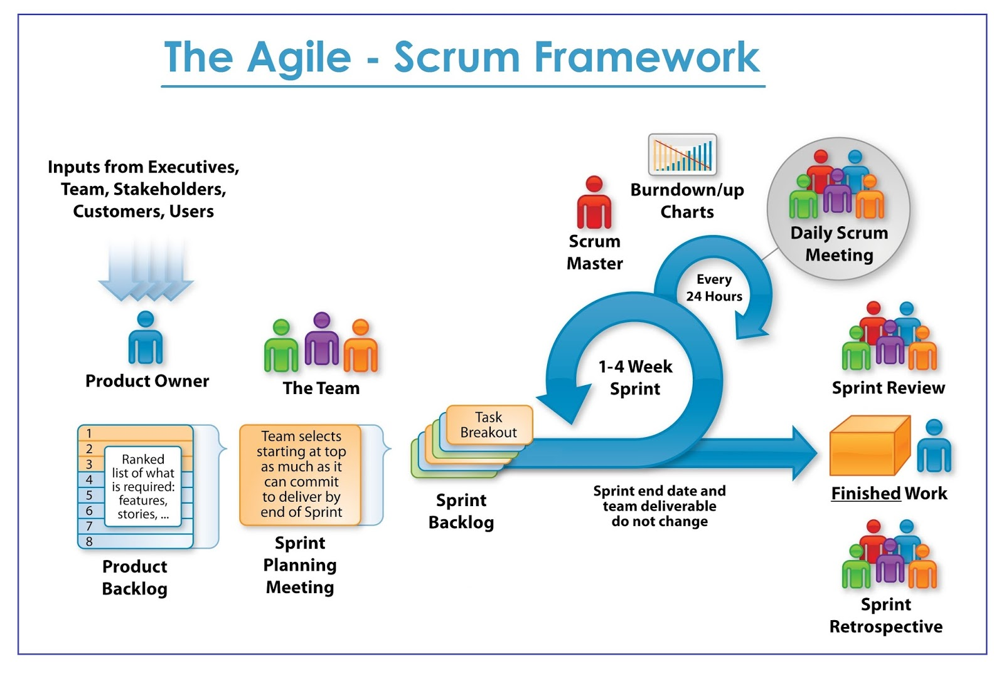

Scrum is the most widely used Agile methodology in practice today. The benefits an organization stands to gain from adopting Scrum are somewhat obvious. Scrum is accommodating, and actually welcomes changing requirements. One way this flexibility is implemented is through product and sprint backlogs. Each sprint, the scrum team and product owner work together to identify the most important features to deliver immediately. These features are evaluated for potential business value and perceived effort. Consequently, a quantitative value is assigned based on this assessment; a priority level. These features are incrementally decomposed until they are small and testable, among other notable qualities. These features are eventually turned into stories, that is, if they are not already simple enough. These features are added to backlogs, and they (backlogs) are what makes Scrum so great in my opinion. There are what I like to call a public (product backlog) and private (sprint backlog) version. The fact that anyone can add to the product backlog further enforces this idea of autonomy that is present among the Agile methodologies we have examined so far. If a member of the scrum team, or the product owner, Scrum master, finds a feature that they view as useful they can add it to the backlog. I see it as a way to have your opinion heard , which is always nice. The sprint backlog is instrumental in guiding the work to be done immediately, which delivers value now. It is a way to separate vision from reality

The disadvantages seem to be the same among Agile practices. One disadvantage I see is from incorrect implementation of the SDLC. The methodology calls for an excessive amount of meetings in my opinion. Even though the meetings are relatively short, their frequency could be an issue. This may be difficult for some organizations to execute successfully. Many times key stakeholders will not be available for these meetings. As a result, a representative with stakeholders best interests in mind may take their spot. This opens the door for miscommunication to occur. When miscommunication and requirements exist, the results may be expected business value not delivered to the customer during a sprint, or at all.

I see Scrum as the most flexible methodology that we have covered up to this point. I like the idea of recurring meetings to ensure that everyone is on the same page. However, I wonder how it works practically. In my experience, the more often meetings occur, the more likely employees are to not take them as seriously. One perceived benefit that may counteract this fact: the tone of the meetings. It doesn't seem like the meetings are meant to track progress in a way that is disciplinary; that is, it appears to me that it doesn't matter so much what you accomplished. The focus is more on removing obstacles, and maintaining a sustainable pace. The “slow and steady wins the race” feel of Scrum may make it difficult to scale up, if needed.

